**5DD – ASSIGNMENT PART 2**

Alessandro Ferro

**Section A**

* Types created
* Tables created
* Primary Keys assigned.

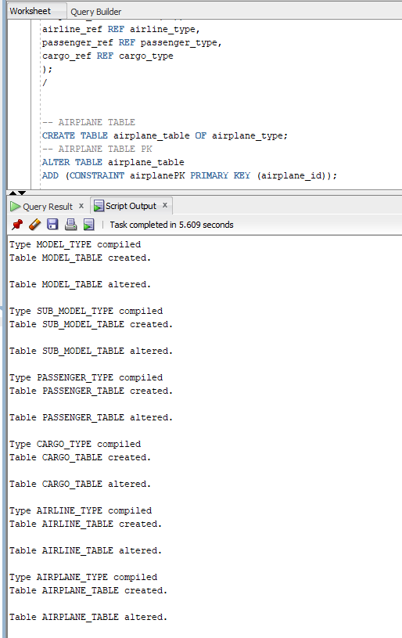

**Section B**

* Test insertion in model_table

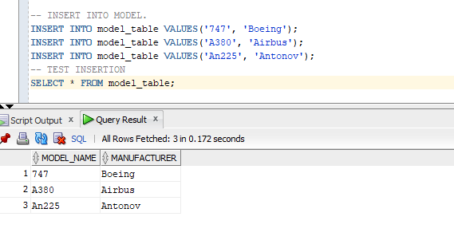

* Testing insertion in sub_model_table

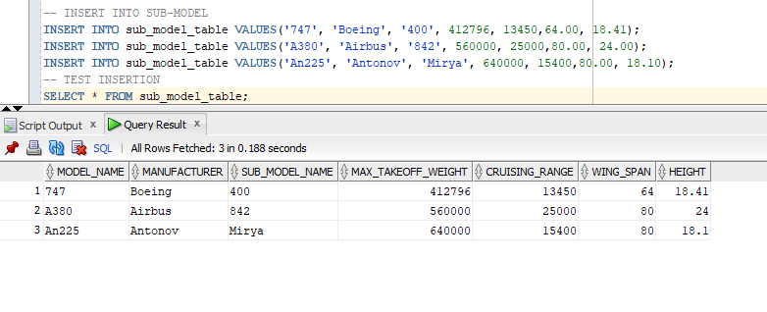

* Testing insertion in passenger_table

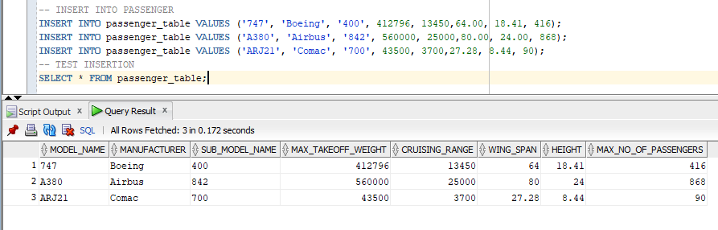

* Testing insertion in cargo_table

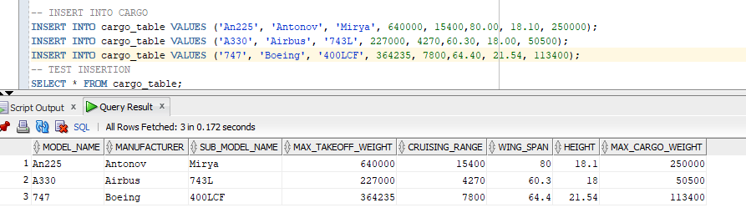

* Testing insertion in airline_table

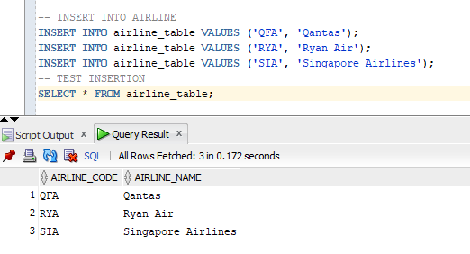

* Testing insertion in airplane_table

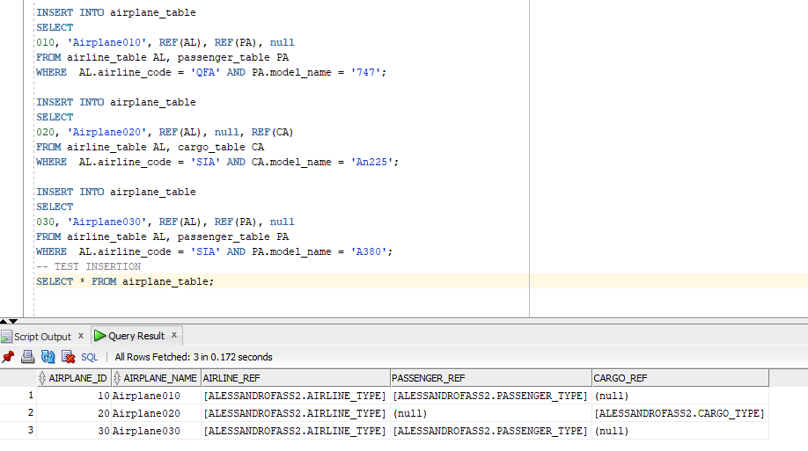

* Testing the method to count the number of airplanes owned by an airline.

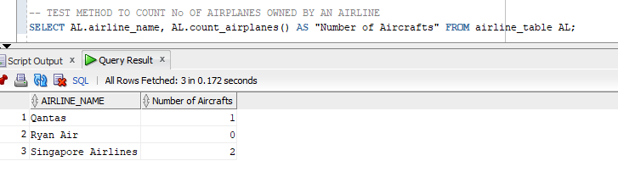

**Section C**

* Login Screen

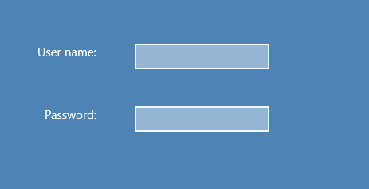

* Airline selection screen

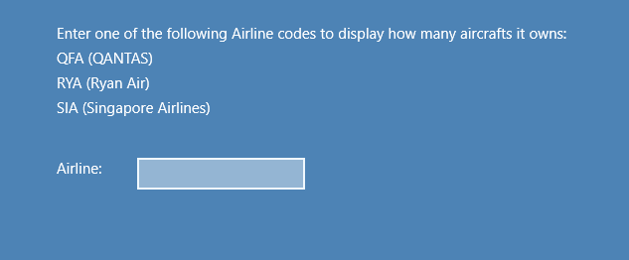

* The code successfully returns the number of aircrafts owned by an airline

